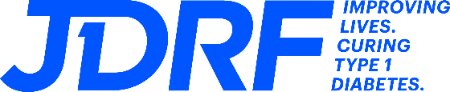
MEDIA ALERT
Contact:Natalie Brislin
Development Manager
Nbrislin@jdrf.org

JDRF One Walk® celebrates community and raises awareness for Type 1 Diabetes Research
JDRF Southern and Central Ohio announces, in conjunction with JDRF International, the 2024 JDRF One Walk Columbus. The reimagined community-based fundraiser brings together members of the Type 1 Diabetes (T1D) community to celebrate, educate, and fundraise for T1D research.
Who: | Sign-up for One Walk is free and open to the public: JDRF One Walk, Columbus 2024 - JDRF One Walk
When: | Sunday April 28th, 2024  Time: Activities begin at 12:00 p.m.
Where: | The Lawn at CAS  2540 Olentangy River Road  Columbus, OH 43202
For more information on the JDRF One Walk visit: www.walk.jdrf.org
About the JDRF One Walk

The JDRF One Walk is your chance to show the world that together, we can conquer type 1 diabetes (T1D). If you're living with T1D or you love someone living with T1D, you'll likely do just about anything to make life easier. Now you can be a part of the largest T1D event in the world, no matter where you are. Your One Walk will power more research, enable more advocacy, and fund more support for the 1.45 million Americans living with T1D. By joining the JDRF One Walk, you'll be part of the lasting footprint we'll make for the T1D community now, and for generations to come.

Celebrate Your Loved Ones
Together, we walk to support the millions of people living with T1D. Whether you have a direct connection to the disease or not, everyone is invited to make a difference as we celebrate our loved ones with T1D.

Help Change Lives
Each year, an estimated 64,000 people in the U.S. are diagnosed with T1D. And, less than one third of those living with T1D are achieving target blood glucose levels — putting them at risk for complications. Let's bring that number to zero.

Contribute to a Cure
If you want to help put an end to T1D, this is your opportunity. By joining JDRF One Walk, you'll support breakthroughs that get us closer to cures — and provide hope to the millions affected by this disease.

Find Your Community
We're a community that's committed to doing whatever it takes to put an end to T1D. When you join JDRF One Walk, you can meet others who have been through similar experiences and find resources, support, and connection.

